**BANK MANAGEMENT SYSTEM**

**Project Report**

INDUSTRIAL TRAINING (CSE 599)

B.Tech (C.S){A.I}[M.L & D.L]

|  |  |
| --- | --- |
| PROJECT GUIDE:  Mr.Tushar Malhotra | SUBMITTED BY:  **Aman Jain(TCA1959051)** |



**FACULTY OF ENGINEERING & COMPUTING SCIENCES**

**TEERTHANKER MAHAVEER UNIVERSITY, MORADABAD**

**ACKNOWLEDGEMENT**

I have taken efforts in this Project (bank management system). However, it would not have been possible without the kind support and help of many individuals and organizations. I would like to extend my sincere thanks to all of them.

I would like to thank my project guide (Mr. Tushar Malhotra), for giving me this and guiding me throughout my work with patience. He has taken pain to go through my project and make necessary corrections as and when needed. Without her guidance and persistent efforts this project would not have been possible.

I extend my gratefulness to my institute’s library and heartfelt thanks to all the faculty members of the college.

Last but not the least I would like to thank my family and my well-wishers. Without you all this project would have been a distant reality.

*Student Name :- AMAN -JAIN*

**Place: Teerthankar Mahavir University**

**Date: 22/12/21**

**DECLARATION**

We hereby declare that this Project Report titled bank management system submitted by us and approved by our project guide (Mr.Tushar Malhotra sir), the College of Computing Sciences and Information Technology (CCSIT), Teerthanker Mahaveer University, Moradabad, is a bonafide work undertaken by us and it is not submitted to any other University or Institution for the award of any degree diploma / certificate or published any time before.

|  |  |  |
| --- | --- | --- |
|  |  | |
| **Student Name:** | Name :- AMAN-JAIN | Signature:- AMAN-JAIN |
|  |  |  |
|  |  |  |
|  |  |  |
| **Project Guide: (Internal)** | Name :- Mr. Tushar Malhotra | Signature |

**Brief About the Company**

Naresh i Technologies (Pronounced: NareshIT) is a leading software training institute providing Software Training, Project Guidance, IT Consulting and Technology Workshops.

Using our enhanced global software training delivery methodology, innovative software training approach and industry expertise, we provide high-value corporate training services that enable our clients to enhance business performance, accelerate time-to-market, increase productivity and improve customer service.

We serve Global 100 companies and the leading software vendors in Banking & Financial Services, Insurance, Telecommunications, Technology and Media, Information & Education industries.  We design and mentor human resources for our clients who create competitive advantage.

Founded in 2004 and headquartered in Hyderabad, India, we have offices and training institutes throughout the India.

Table of Contents

1 Project Title 6

2 Problem Statement 6

3 Project Description 6

3.1 Scope of the Work 6

3.2 Project Modules 6

3.3 Context Diagram (High Level) 6

4 Implementation Methodology 6

5 Technologies to be used 6

5.1 Software Platform 6

5.2 Hardware Platform 7

5.3 Tools, if any 7

6 Advantages of this Project 7

7 Assumptions, if any 7

8 Future Scope and further enhancement of the Project 7

9 Project Repository Location 7

10 Conclusion 8

11 References 9

**Appendix**

**A: Data Flow Diagram (DFD)**

**B: Entity Relationship Diagram (ERD)**

**D: Data Dictionary (DD)**

# Project Title :- BANK MANAGEMENT SYSTEM

# Problem Statement :-

Cash, Enquiry and Account related updated information needed to customer on daily basis and Visiting Bank Branch for Deposit , Cash withdrawal and Transaction become hectic for user .In this Project we are try to get rid of this by just to implement the simple ,user friendly simulation for user .

# Project Description:-

The project main objective is to provide the simple , user friendly simulation which help bank management to manage their customer

Here user get updated information regarding Transaction, Cash withdrawal and Deposit Money.

Also if user want to enroll for the service then they can create their own account by just signup in the page.

Here in this Project we introduce the eight mode in this simulation

* Deposit
* Fast Cash
* Login
* Mini Statement
* Pin
* Signup Page 1
* Signup page 2
* Signup Page 3
* Withdrawal
* Transaction
* Connection

Starting from login page

**Login Page**: In This mode User enter their Card Number and their confidential pin for sign In . Also user can also enroll for this service

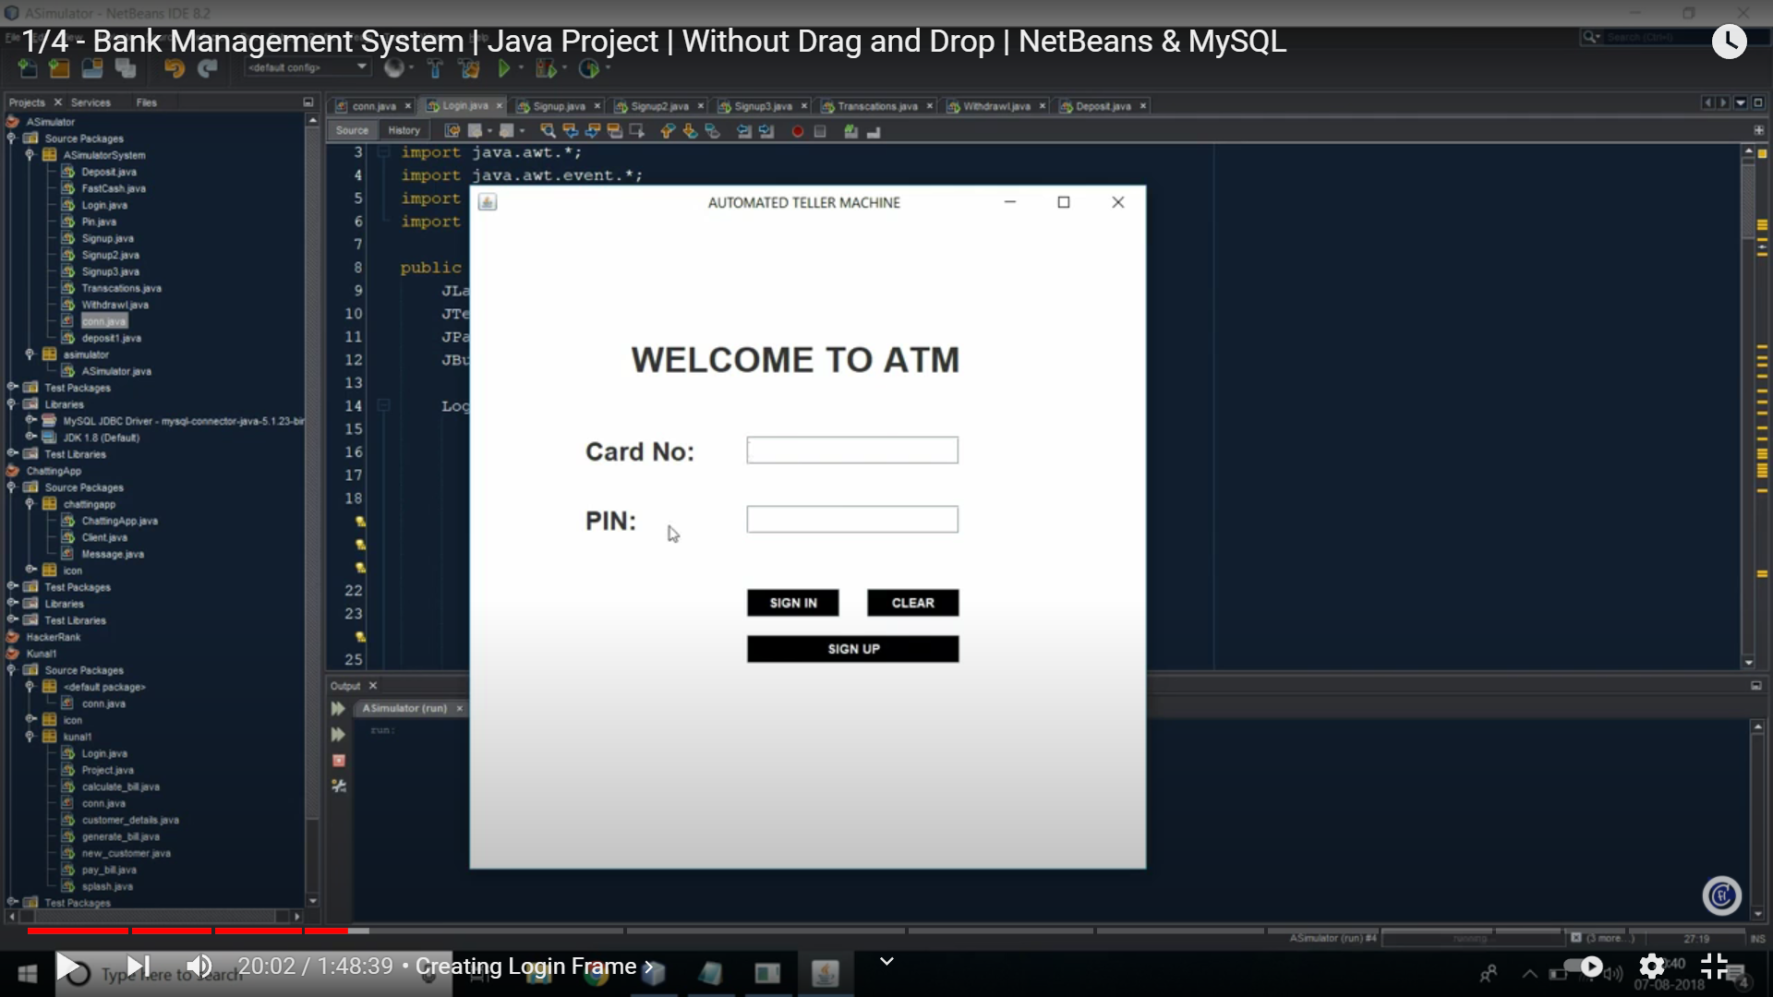

**Signup Page:** Here in this User enter personal Detail for this service .

**Signup page1:** In this User fill their name , father name , email Id, Address , Martial status etc.

This is identity of user which use this service

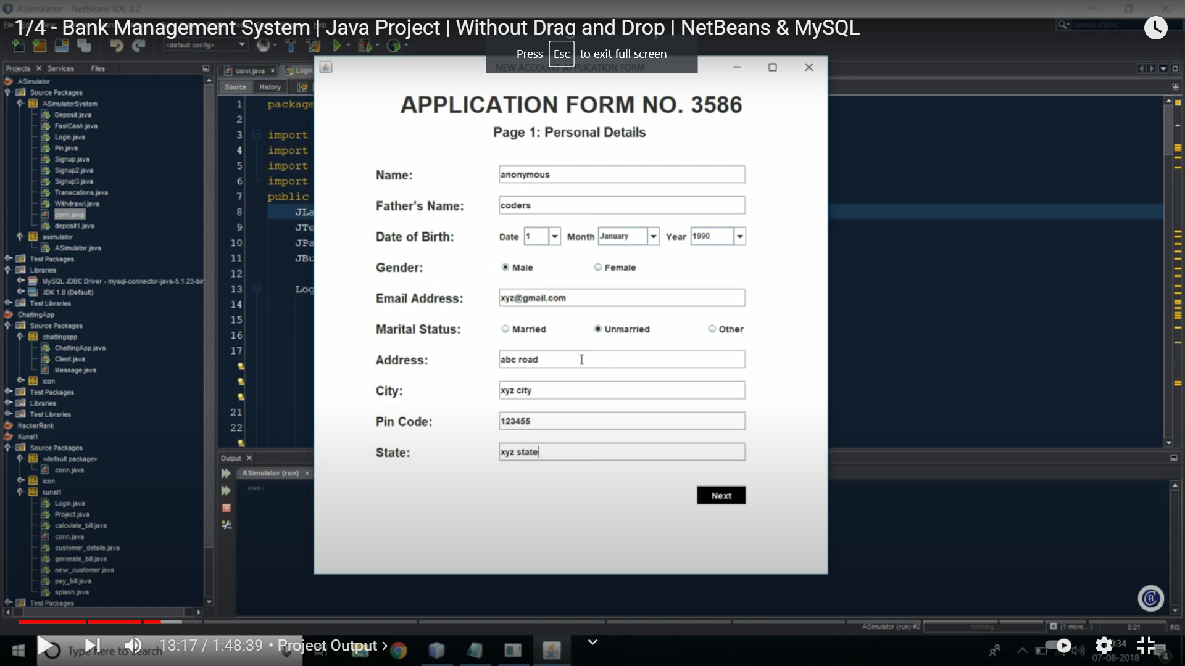

**Signup Page 2:**

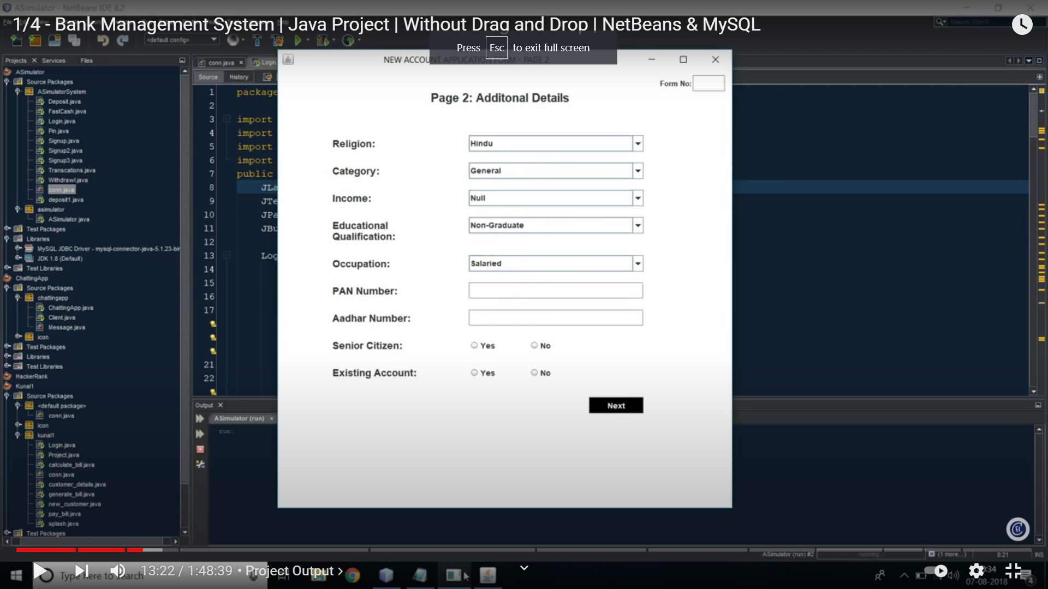

In this Additional Detail need from the customer to know about more

**Signup Page 3:**

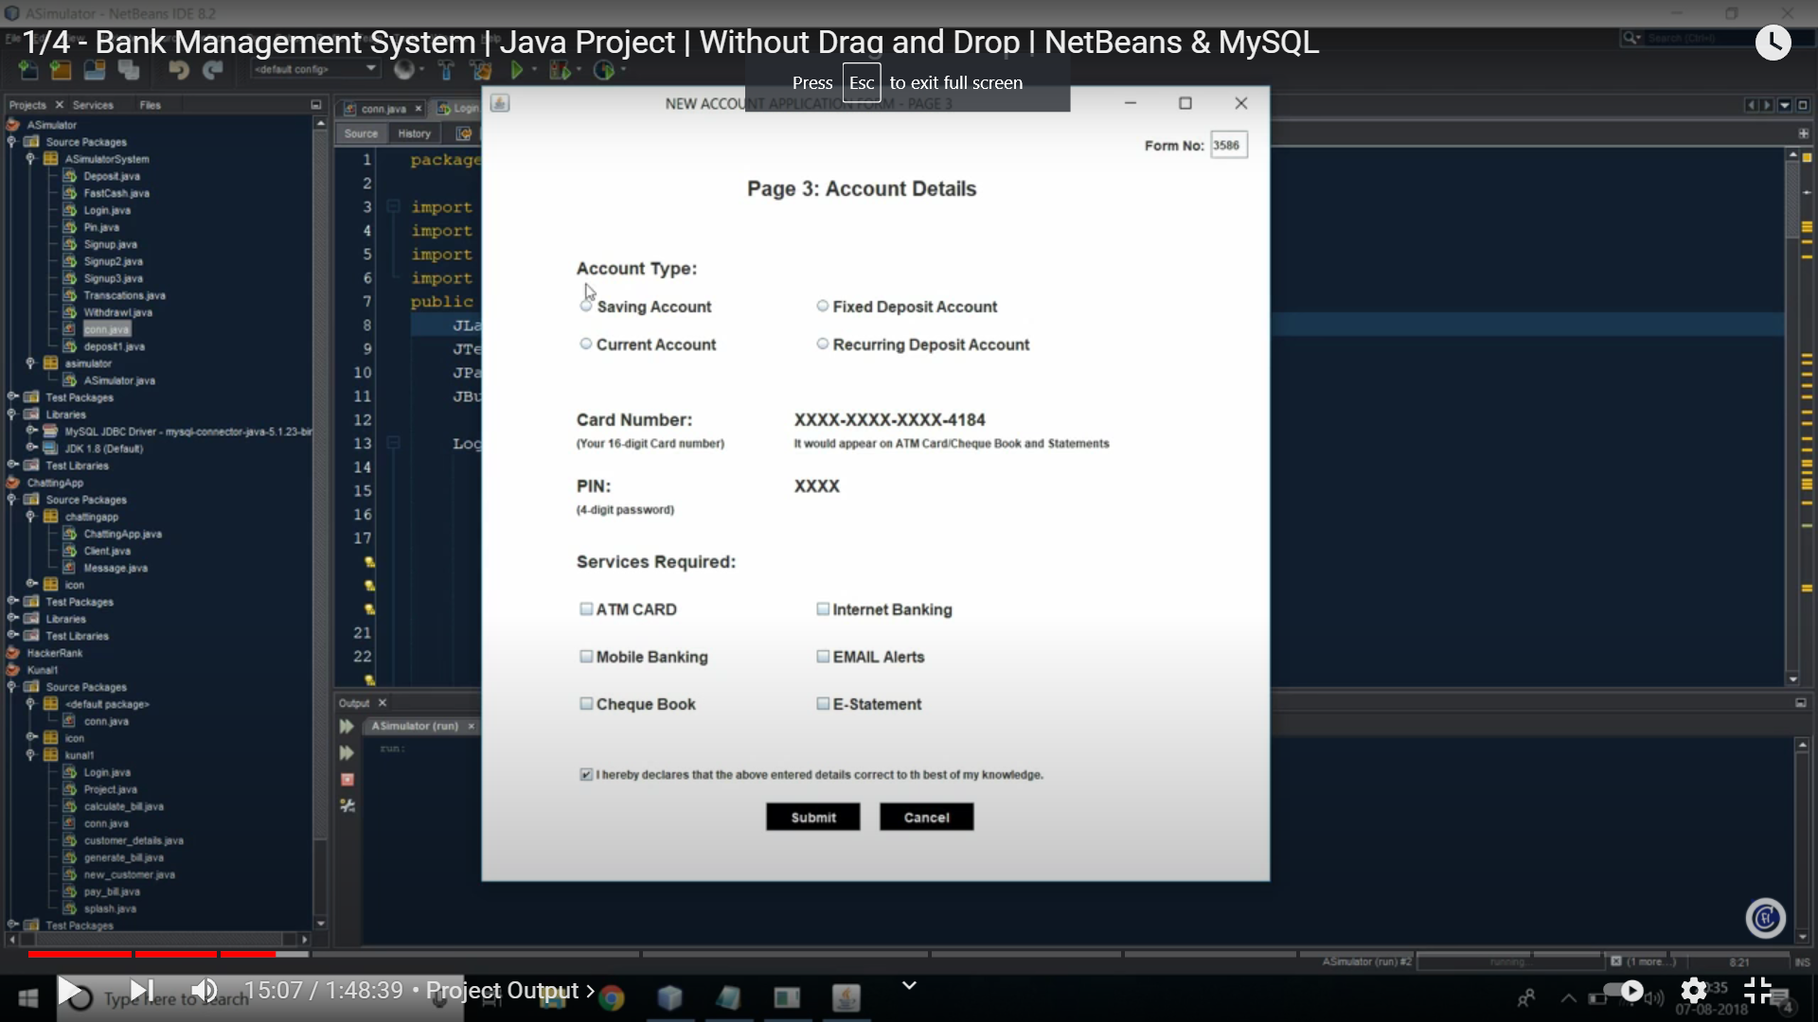

Gather information about Account type , Service required option for which the account to be use.

**Deposit:** Here the money get Deposit into the Respected Account login that time .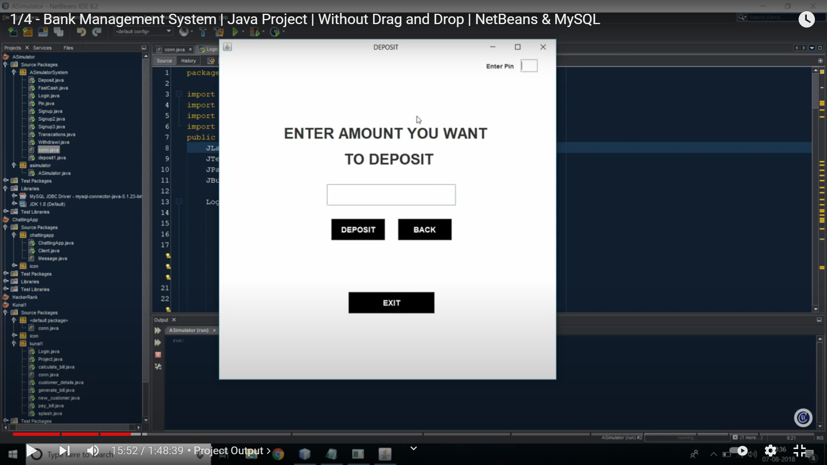

**Withdrawal:** Here the Amount of money get Detected from the account linked with them

**Transaction :** Here it is an interface where user can get all related account detail like mini statement, enquiry , withdrawal , Deposit

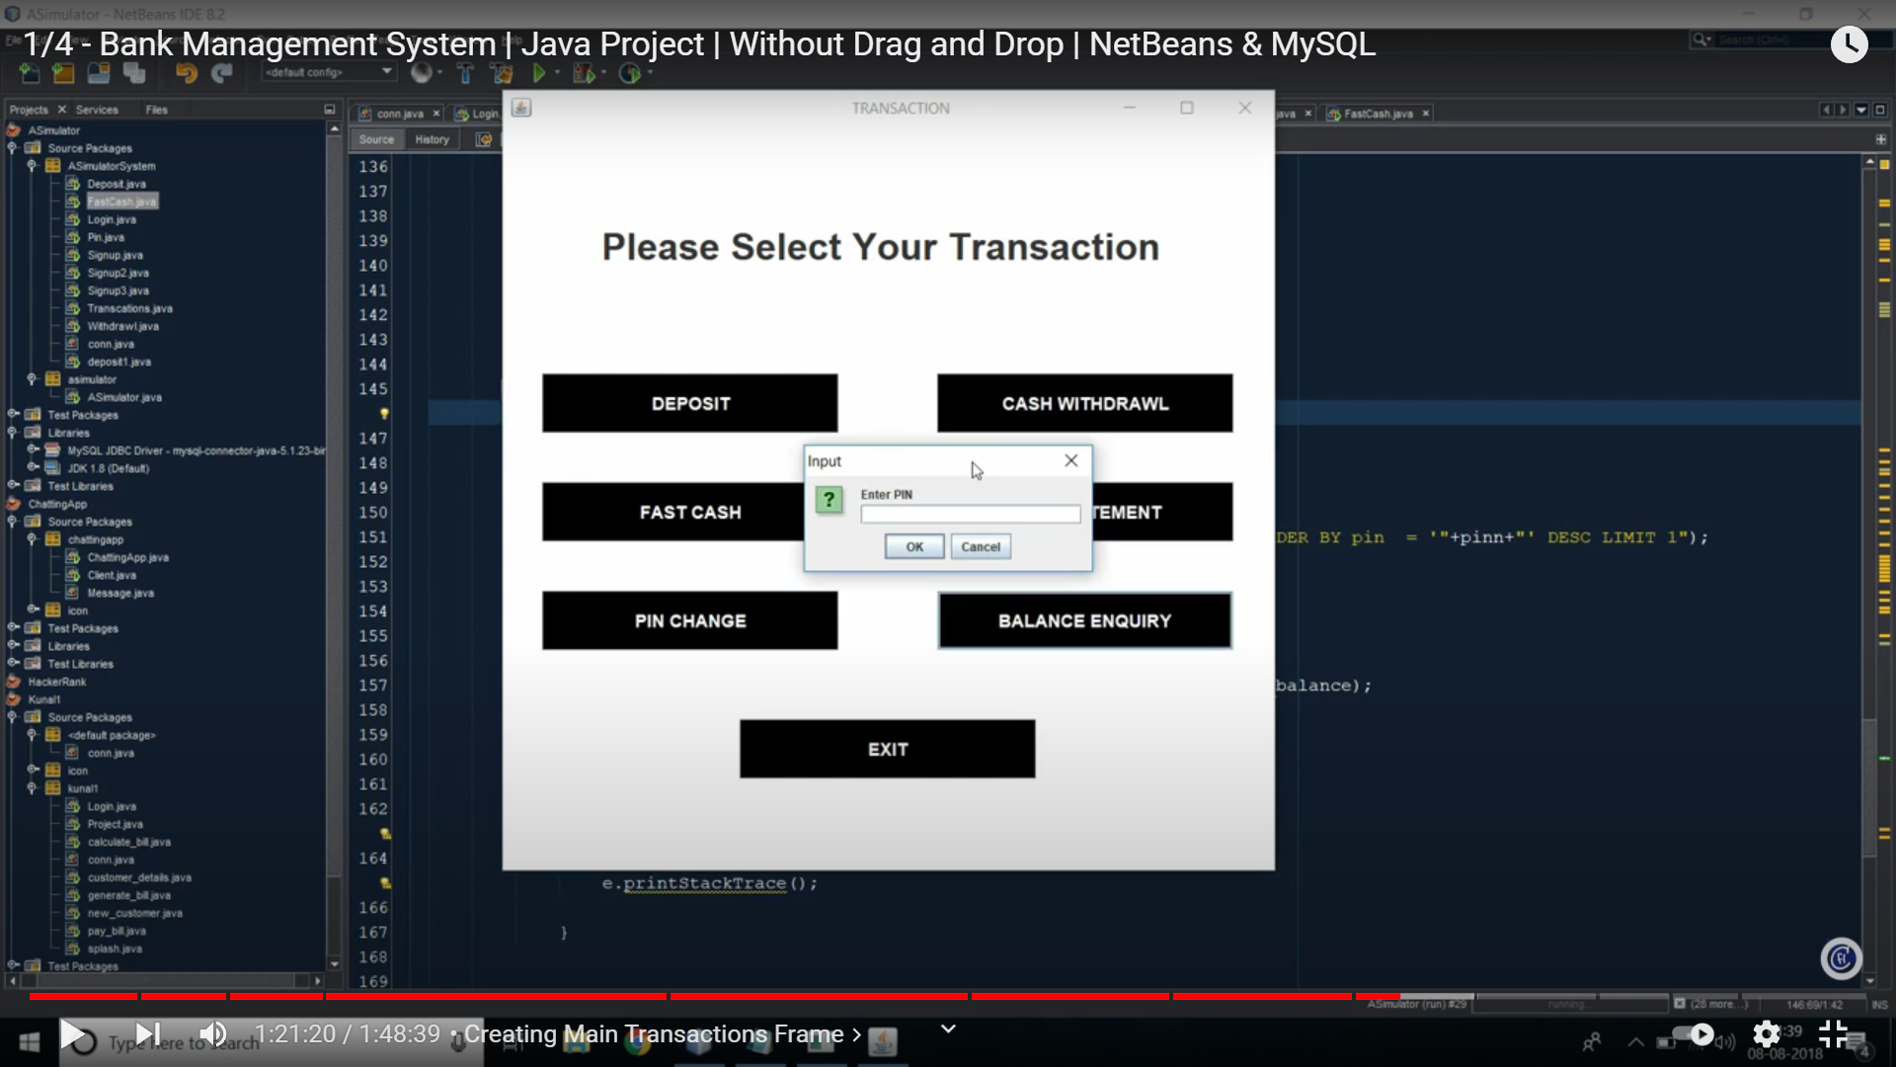

# Implementation Methodology:

registration

aadhar

aadress

city

gender

DOB

email

transaction

Forget password

Successful login

login

Already resigistred

user

name

transcat

deposit

# Technologies to be used:

## Software Platform

* + 1. **Front-end : java**

* + 1. **Back-end : java , mysql**

## Hardware Platform

### RAM, Hard Disk, OS, Editor, Browser etc.

## 5. 3 Tools:

**Operating System: Windows 10**

**6. Advantages of this Project :-**

The advantage of this project is to make things easy and get faster access to customer’s and staff. The users of this project get more comfortability in their work and get better experience .

* This project is developed to nuture the needs of a user in a banking sector by embedding all the tasks of transactions taking place in a bank.
* The withdrawal is more then 8000, with instant balance enquiry and also check account balance.
* The deposited or withdrawal amount update instantly.You can create account anywhere by your phone, by the help of this application account can be created in few minutes

# 7. Assumptions, if any :- none

# 8. Future Scope and further enhancement of the Project

This project will enhance the customer or member’s and the branch to serve more quickly and efficiently. This software is developed in order to computerize the activities which take more time, if done manually.

Bank many services like withdraw or deposit, spot update will enable the customer and staff to make things faster and can get information quickly. If we want any information about customers of bank, we can access it quickly.

# 9. Project Repository Location :- <https://github.com/Amanjain6020/bank-> management-system.git

# 

# 10. Conclusion

This project is developed to nurture the needs of a user in a banking sector by embedding all the tasks of transactions taking place in a bank. Future versions of this project will still be much enhanced than the current version.

Thus the Bank Management System is developed and executed successfully.

# References

1. javatpoint
2. <https://www.researchgate.net/publication/301293322_Bank_Account_Management_System>
3. https://www.youtube.com/watch?v=2_cJa4h9wdY

**Annexure A**

**Data Flow Diagram (DFD)**

**(Mandatory)**

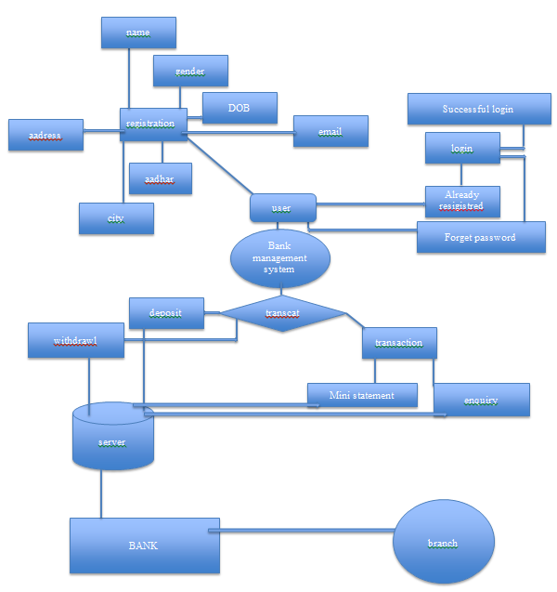

**Annexure B**

**Entity-Relationship Diagram (ERD)**

**(Mandatory)**

**General used cases**

1 Manage customer info and status

2 manage/update customer info

3 manage withdrawing and saving account transaction

4 record all transaction

**ADMIN**

**USER**

**Annexure D**

**Data Dictionary (DD)**

**(Mandatory)**

**Example:**

**User Table (USR)**

|  |  |  |
| --- | --- | --- |
| **Fields** | **Data type** | **Description** |
| USR-Name | Text | Admin name |
| USR-Password | Text | Admin password |
| USR-Contact-No | Number | Admin Contact |
| USR-Address | Text | City |

**Supplier Table (SUPP)**

|  |  |  |
| --- | --- | --- |
| **Fields** | **Data type** | **Description** |
| SUPP-ID | Number | Supplier ID |
| SUPP-Name | Text | Supplier Name |
| SUPP-Address | Text | Supplier Address |
| SUPP-Contact | Number | Supplier Contact |
| SUPP-Credit-Limit | Number | Credit Limit |